ECE 3441 – Fall 2025

Lab 1: TTL Characteristics and SimUAid

Anaya Scott

Overview: Goals of the Lab
This lab discusses the basics of logic circuits using the 74LS00 chip. We learned how to read TTL chip’s spec, function, characteristics, and conditions in a manufacturer’s datasheet. This lab will include the use of SimUAid simulation for logic circuits. The goal of this lab is to learn and understand how to read the datasheet if a 74SL00 and build a logic design of the

Step-by-Step Procedures and Results

Part 1: Understanding the 74LS00 TTL Chip
Question 1: What is DIP packaging? Include a figure containing an image of a 74LS00 chip in DIP packaging. Try to make sure the part number is visible! Hint: you have one in your lab kit. [1]
DIP packaging is a Dual In-line Package, which is a type of housing for integrated circuits. It has 2 rows of pins used for integrated circuits and other components. Usually mounted on a PCB board. Representing the NAND logic gates, which can also be known as the Quad 2 input NAND gate. Having a total of 20 input pins (5 gates) and 4 output pins.
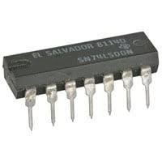

https://encrypted-tbn0.gstatic.com/images?q=tbn:ANd9GcRW0ellogysbNqN200NOezAVGjtdwRKH1UW1A&s
Question 2: There are five fields in part number SN-74-LS-00-N. Explain what each field tells you about the chip. Applying this breakdown to the chip in your lab kit, how might this influence which datasheet you use, if you found more than one. [1]
SN means Semiconductor Network, which will tell you who is the manufacturer of the chip.
74 means the Series and Temperature Grade of the chip, generally the series temperature range will sit around 0 C to 70 C. military grade components will generally be in the -55C to 125C range.
LS means the Logic Family, indicating the speed and power consumption which can also be called the Low power Schottky.
00 means it is the device number that can tell what the chip will do. Not that 00 is the universal meaning for Quad 2 input NAND gates.
N means the package type, denoting a plastic Dual Inline Package.
This might influence which datasheet that we can use because …
Question 3: Using the datasheet, how many total inputs and outputs are there in this TTL chip? How many inputs are used to generate each output? Include a figure of the pinout diagram.[1]
It has 8 inputs, 2 per gate for every 4 gates, and 4 outputs, 1 per gate.
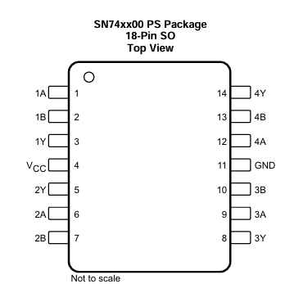
Question 4: Using the datasheet, what are pins 7 and 14 used for? What does the little notch in the plastic case do? [1]
Pin 14 is known as Vcc, this represents the supply voltage for the device. This pin has a maximum voltage of 7V. Pin 7 is known as the GND, which is the ground pin. That allows the device to be grounded.
Question 5: Provide a link to the datasheet you are using for this lab. [1] https://www.ti.com/lit/ds/symlink/sn74ls00.pdf

Part 2: TTL Characteristics of the 74LS00 TTL Chip
Name: | Value or Range | Units:
VOH_min | 2.5 | [V]
VIH_min | 2 | [V]
VIL_max | 0.8 | [V]
VOL_max | 0.5 | [V]
VCC | 4.75 <5.25 | [V]
IOL_max | 8 | [mA]
IOH_max | -0.4 | [mA]
IIL_max | -0.36 | [mA]
IIH_max | 20 | [µA]

Questions 6: Briefly summarize what each parameter above means.[1]
VOH_min = The lowest voltage output a chip can produce.
VIH_min = The minimum voltage of the input pin
VIL_max = the maximum of the lower-level input voltage.
VOL_max = the maximum of the lower-level output voltage.
VCC= The power supply source.
IOL_max= the maximum low current of the output pin.
IOH_max = the maximum high current of the input pin.
IIL_max = the maximum low current that can flow into the input pin.
IIH_max = the maximum high current that can flow into the input pin.

Question 7: What does positive logic and negative logic refer to? [1]
Positive Logic: Low voltage = 0, High voltage = 1.
Negative Logic: Low voltage = 1, High voltage = 0.
Question 8: Explain what fan-in and fan-out mean. Determine the fan-in and calculate the fan-out of a single logic gate in the 74LS00 TTL chip. (Remember: fan-out needs to be calculated for both logical high and logical low outputs, just in case one is smaller). What should you do in your circuit to comply with fan-out? [1]
Calculations:
IOL_max = 8[mA], IIL_max= -0.4[mA], IOH_max = -0.4[mA], IIH_max = 20[µF]

$$Fan out_L=\frac{IOLmax}{IILmax}=8\frac{\left[mA\right]}{-0.4 [mA]}= -20=20[A]$$
$$Fan out {}_{H}^{}=\frac{IOHmax}{IIHmax}= -0.4\frac{\left[mA\right]}{20 \left[µF\right]}=-20=20[A]$$
$$Fan in=the number of inputs per outputs=2$$
Fan in is the maximum input that a gate can get.
Fan out is the number of inputs that an output can reach.
Question 9: Explain what pull-up and pull-down resistors are. What happens if you don’t put them when you use DIP switches as inputs to your TTL chips? (Hint: research “floating input voltage”). [1]
Pull up resistor = weakly pulls the voltage of a line UP to the logic high level, when no other device is actively pulling it down.
Pull down resistor = weakly pulls the voltage of a line DOWN to the logic low level, when no other device is actively pulling it up.
If the resistors are not in an open switch it will lead to erratic results.

Question 10: Calculate the maximum pull-up and pull-down resistances for a single logic gate input in the 74LS00 TTL chip using the specifications you put in the table above. Remember: if the resistances are too high, the pull-up/pull-down resistors don’t connect the input to ground or 5 [V] well, and you get invalid input voltage levels. Your objective is to find the largest resistance such that the input low voltage stays below VIL_max (for pull downs), and such that the input high voltage stays above VIH_min (for pull-ups). The currents that pass through the inputs are on the table. Watch your units! Show your work and ask for clarification if you need it. After you’ve finished, explain in your own words why these limits are important.
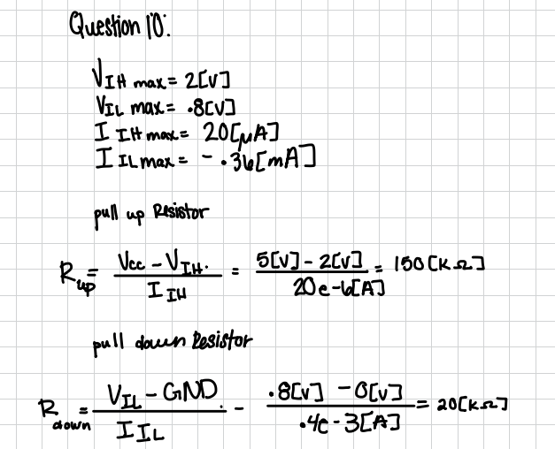

Question 11: In practice, you will connect many logic gate inputs to one pull-up/pull-down resistor. Assuming the characteristics of the 74LS00 TTL chip, consider what happens if you connect n logic gate inputs to a single pull-up/pull-down resistor. Since having n gates multiplies the total current through the resistor by n times, briefly repeat the calculations from Question 10, but with n times the current. How do you modify your pull-up/pull down resistor limit formulas to support n gates?[1]
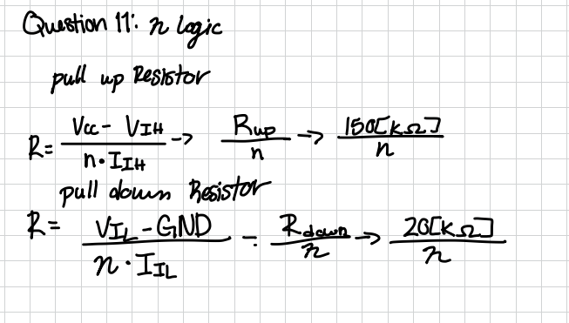

Part 3: Simulation using SimUAid

Task:
Build the logic circuit of the 74LS00 in SimUAid or LTspice and perform the same analysis from the example.

If the 74LS00 is a combination AND, OR, or NOT gates, we expect you to build two circuits that are equivalent to each other, and that both use the same combination of inputs. Show that your input and output values match the ones in the datasheet. Make sure you label your inputs, your logic gate(s), and your output(s). Make sure to label your figures and tables accordingly.

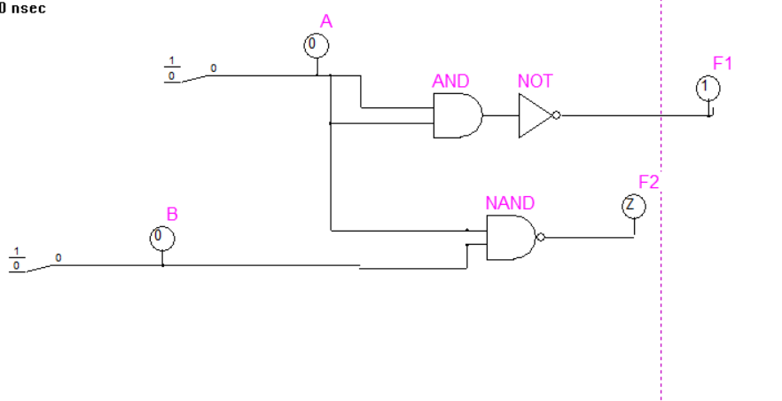
Table 1: Truth Table for a NAND gate.
Inputs |  | Output
A | B | F1 | F2
0 | 1 | 1 | 1
0 | 0 | 1 | 1
1 | 0 | 1 | 1
1 | 1 | 0 | 0

Conclusion
Overall, in this lab report, I learned to read a data sheet of a 74LS00, understanding the basic vocabulary of the electrical components of a chip. While learning the methods of a fan in/ fan out, and pull up and down resistors, understand the maximum threshold of what the Voltage and Current of high\ low level of the logic system While also learning how to navigate SimUAid system and put that information into a truth table.

